

Orchard management app gui planning

COMP.6215 Graphical User Interface Programming



March 2, 2020

Lukas jeremias roessner

30021032

Table of Contents

**Concept2**

Initial Idea2

Initial Mind Map3

Final Mind Map4

**Structure5**

Simple Structure5

Detailed Structure and Pathways6

**Interaction7**

Login Form7

Main Page8

View Harvests9

View Actions10

Add Section11

Edit Section12

Add Harvest13

View Harvest14

Edit Harvest15

Add Action16

View Action17

Edit Action18

**Mood Board19**

# Concept

## Initial Idea

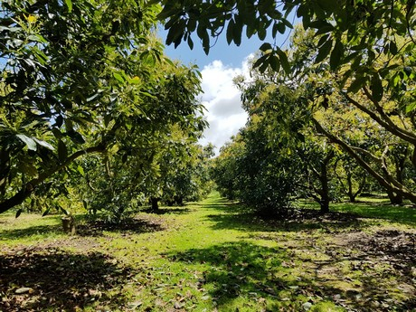An Orchard Management App to help keep a tidy, and precise, log of everything happening to your orchard and saving this data into a database. This will make the data very usable and accessible in the future, with space for future development of the App. The App will be aimed at small to medium sized orchards that are looking for a simple but powerful way of recording their actions taking place on their orchard.

Some features of this App will include:

* A Main Map, displaying different sections and their names so identifying what parts of the land have what plants, what actions were made where, and other information is fast and simple.
* Saving Multiple ‘Sections’ of the orchard with information like their name, type of plants on this section, when they were planted, etc.
* Recording ‘Actions’ that will include things like spraying, weeding, fertilizing, pruning, etc. The App will also record things like dates, time, hours spent, and any extra comments made by the owner/workers.
* Recording Harvests from the orchard. This will include things like the total amount of fruit picked, the price received per kg, dates when the orchard was picked as well as any comments from the owner/workers.
* A simple, clean interface to help navigate through the information fast and effectively

## Initial Mind Map

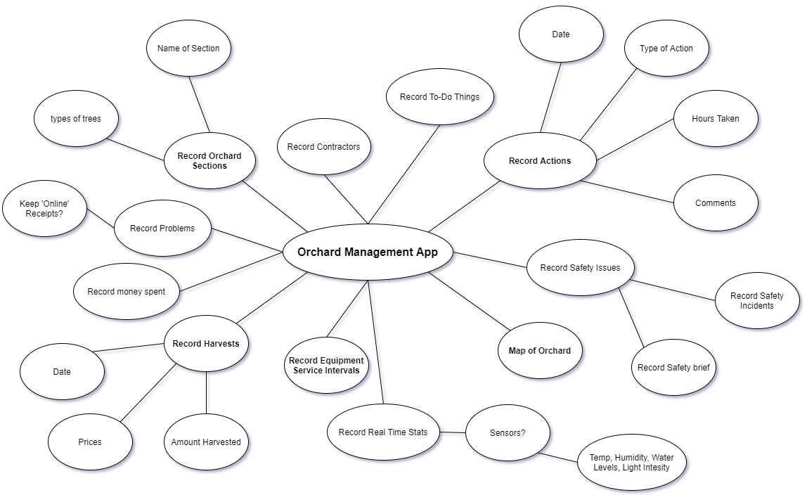

## Final Mind Map

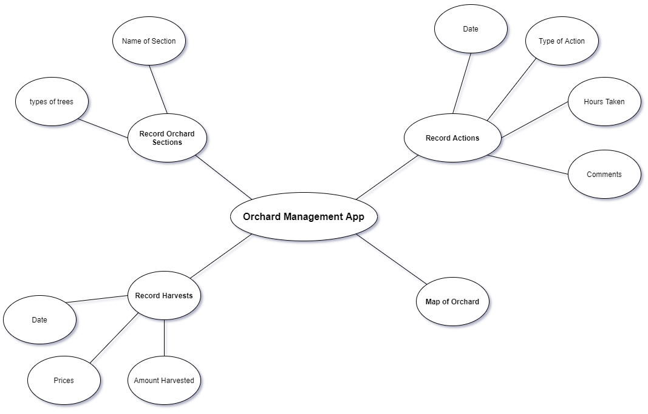

# Structure

## Simple Structure

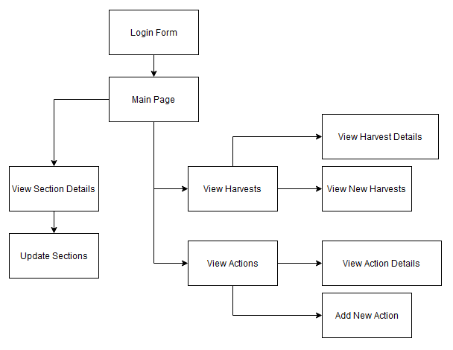

## Detailed Structure and Pathways

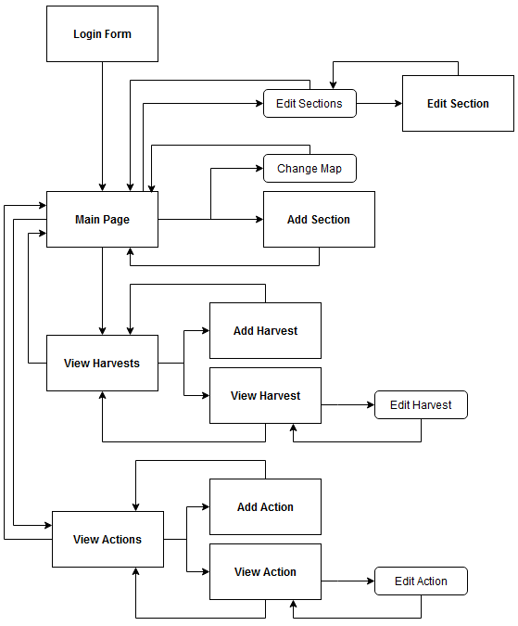

# Interaction

## Login Form

Login button, checks login details and directs to the main page if they are correct

Two text boxes for the username and password

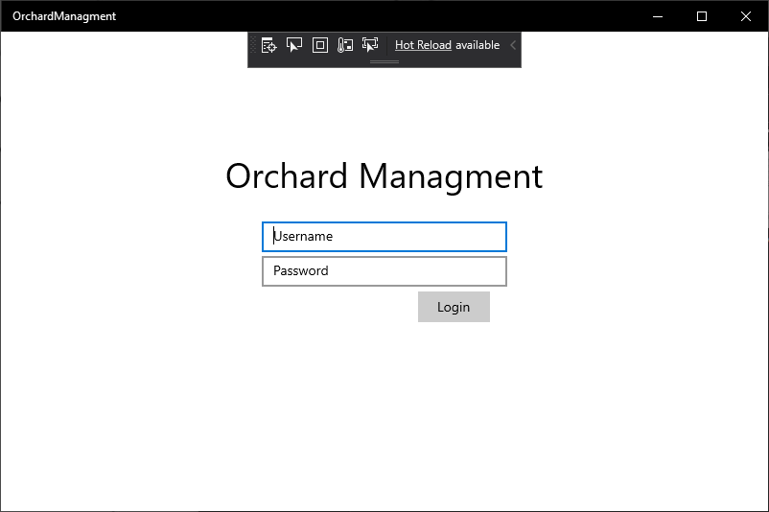

### Main Page

Prompts the user to select a new image file

Displays the Add Section form

Shows all the harvests for the specific section

Shows all the actions for the specific section

Main Map of the property

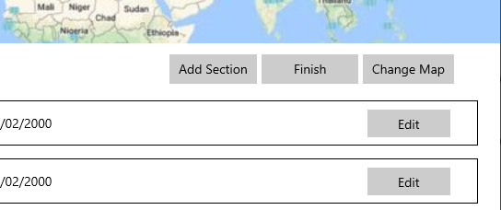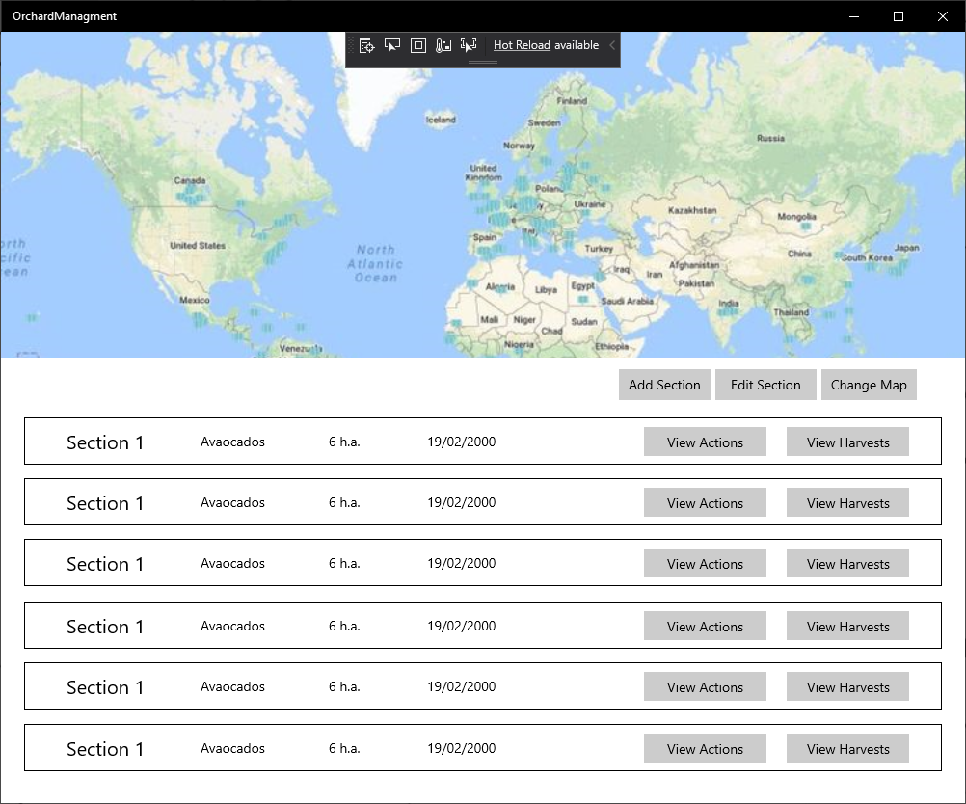

A Single Section, with all its details

Hides all ‘View Actions’ and ‘View Harvests’ buttons, and replaces them with ‘Edit Section’ buttons

## View Harvests

Navigates to ‘Add Harvest’

Shows all the harvests details, by navigating to ‘Show Harvest’

A single harvest with some of its main details

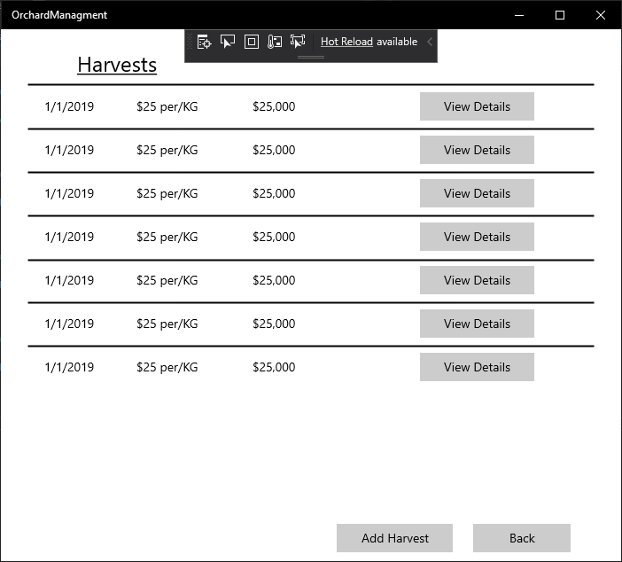

Navigates back to the ‘Main Page’

## View Actions

Opens ‘Show Action’ displaying all information available for the specific action

Displays a single action on each line, displaying the main information

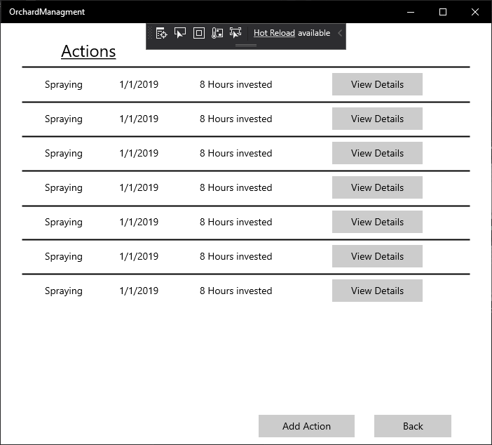

Navigates back to the ‘Main Page’

Opens ‘Add Action’ which lets you add a new action

## Add Section

Comment for the new Section

Date Planted for the new Section

Size for the new Section

Tree Type for the new Section

Name for the new Section

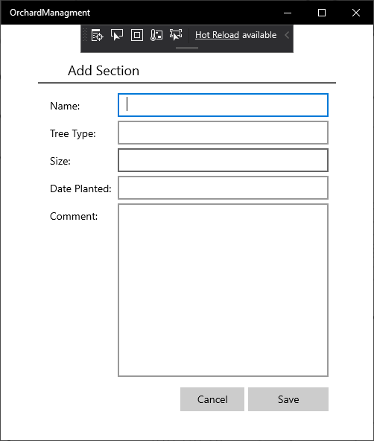

Save the new section and navigate back to ‘Main Page’

Navigate back to ‘Main Page’

## Edit Section

Date Planted of the section

Comment of the section

Tree Type of the section

Size of the section

Name of the section

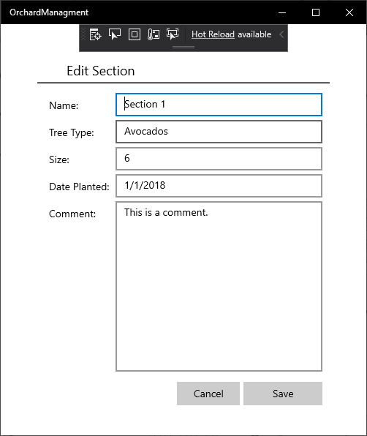

Saves the section and navigates to the ‘Main Page’

Cancel, navigates to the ‘Main Page’

## Add Harvest

Date of this harvest

Total Income of this harvest

Price/kg of this harvest

Comment of this harvest

Kg Harvested of this harvest

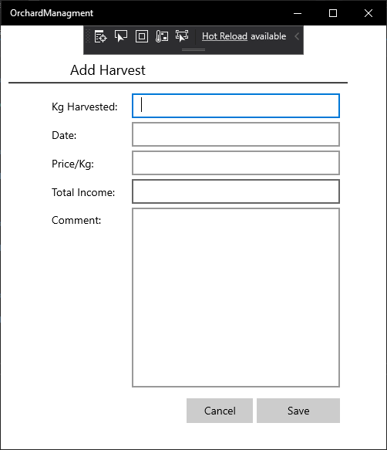

Does not save the current harvest and navigates back to ‘View Harvests’

Saves the new harvest and navigates to ‘View Harvests’

## View Harvest

Price/kg of the harvest

Comment of the harvest

Total Income of the harvest

Date of the harvest

Kg Harvested of the harvest

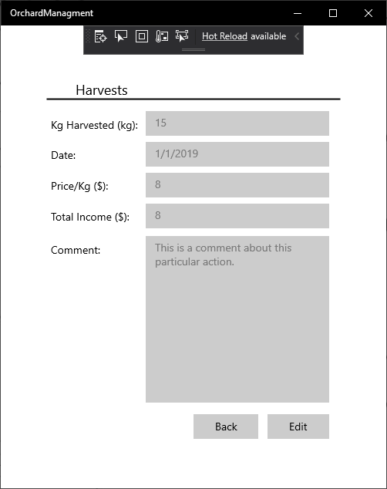

Makes all the fields editable, looking like ‘Edit Harvest’

Navigates back to ‘View Harvests’

## Edit Harvest

Price/kg of the harvest

Date of the harvest

Kg Harvested of the harvest

Comment of the harvest

Total Income of the harvest

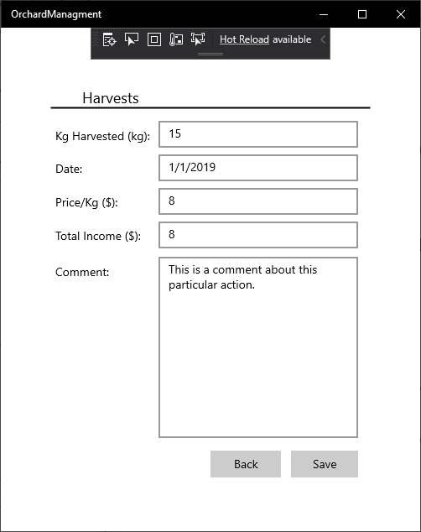

Save the harvest and navigate back to ‘View Harvest’

Navigate back to ‘View Harvest’

## Add Action

Comment of the section

Hours Invested of the section

Type of the section

Date of the section

Save the new action and navigate back to the ‘View Actions’

Back button, navigates to ‘View Actions’

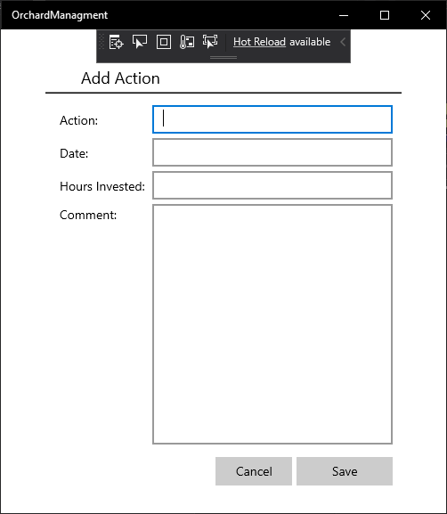

## View Action

Comment of the section

Hours Invested of the section

Type of the section

Date of the section

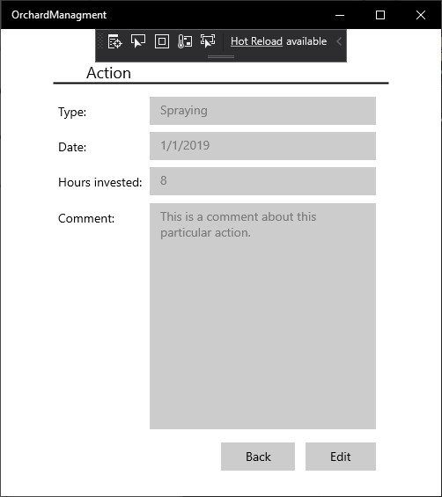

Edit the section, by enabling all the text boxes, changing the view to ‘Edit Action’

Back button, navigates to ‘View Harvests’

## Edit Action

Comment of the section

Hours Invested of the section

Date of the section

Type of the section

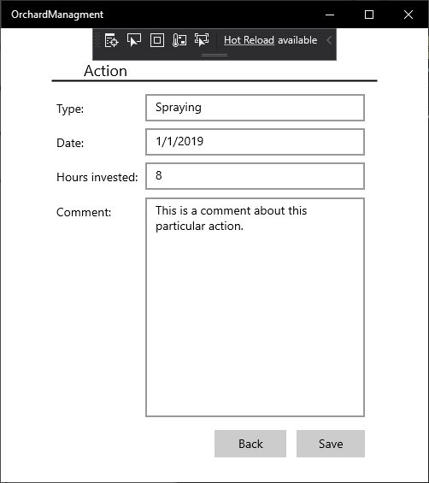

Back button, navigates to ‘View Action’

# Mood Board

Save the current action and navigate back to the ‘View Action’